# Name: Aaryan Ranaut UID:23BCC70032

# ADBMS Experiment - 12

## Aim:

To demonstrate deadlocks, MVCC, and transaction concurrency control in a student enrollment system.

## Theory:

### Part A: Deadlocks in DBMS

A deadlock occurs when two or more transactions wait indefinitely for resources locked by each other.  
Example:  
• Transaction 1 locks row A and waits for row B.  
• Transaction 2 locks row B and waits for row A.  
  
Most modern DBMS (MySQL InnoDB, PostgreSQL) detect deadlocks automatically and roll back one transaction to resolve it. Deadlocks can be avoided by consistent transaction ordering or using row-level locks carefully.

### Part B: MVCC (Multiversion Concurrency Control)

MVCC allows readers and writers to work concurrently without blocking each other.  
• Readers see a snapshot of data at the start of the transaction, unaffected by concurrent writes.  
• Writers create a new version of the data; old versions remain visible to readers until their transactions commit.

### Part C: Comparing Locking vs MVCC

Traditional Locking: Readers may block if a writer holds a lock (e.g., SELECT FOR UPDATE).  
MVCC: Readers see consistent snapshots; writers update without blocking readers.  
  
MVCC improves concurrency, performance, and user experience in high-concurrency environments.

## Code:

### Part A: Simulating a Deadlock

-- Drop table if exists  
DROP TABLE IF EXISTS StudentEnrollments;  
  
-- Create table  
CREATE TABLE StudentEnrollments (  
 student_id INT PRIMARY KEY,  
 student_name VARCHAR(100),  
 course_id VARCHAR(10),  
 enrollment_date DATE  
);  
  
-- Insert sample data  
INSERT INTO StudentEnrollments VALUES  
(1, 'Ashish', 'CSE101', '2024-06-01'),  
(2, 'Smaran', 'CSE102', '2024-06-01'),  
(3, 'Vaibhav', 'CSE103', '2024-06-01');

### Part B: Using MVCC for Non-Blocking R/W

-- Session 1 (User A) reads the record  
START TRANSACTION ISOLATION LEVEL REPEATABLE READ;  
  
SELECT * FROM StudentEnrollments WHERE student_id = 1;  
-- Output: enrollment_date = 2024-06-01  
  
-- Session 2 (User B) updates the same record concurrently  
START TRANSACTION;  
  
UPDATE StudentEnrollments SET enrollment_date = '2024-07-10' WHERE student_id = 1;  
  
COMMIT;  
  
-- Session 1 still sees enrollment_date = 2024-06-01 until commit  
COMMIT;  
  
SELECT * FROM StudentEnrollments WHERE student_id = 1;  
-- Output: enrollment_date = 2024-07-10

### Part C: Comparing Locking vs MVCC

-- Without MVCC  
-- Session 1  
START TRANSACTION;  
SELECT * FROM StudentEnrollments WHERE student_id = 1 FOR UPDATE;  
  
-- Session 2 tries  
UPDATE StudentEnrollments SET enrollment_date = '2024-08-01' WHERE student_id = 1;  
-- Session 2 is blocked until Session 1 commits  
  
-- With MVCC  
-- Session 1  
START TRANSACTION ISOLATION LEVEL REPEATABLE READ;  
SELECT * FROM StudentEnrollments WHERE student_id = 1;  
  
-- Session 2 updates concurrently  
UPDATE StudentEnrollments SET enrollment_date = '2024-09-01' WHERE student_id = 1;  
  
COMMIT;  
  
-- Session 1 still sees old value (2024-07-10) until commit  
COMMIT;

## Output:

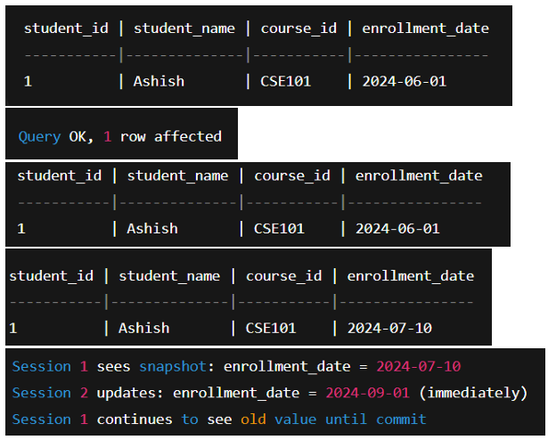

## Learning Outcomes:

1. Learned to enforce unique constraints to prevent duplicate student enrollments.  
2. Understood row-level locking using SELECT FOR UPDATE to handle concurrent transactions.  
3. Observed how transactions preserve Atomicity and Consistency in a multi-user environment.  
4. Practiced handling blocked transactions and understanding isolation effects.  
5. Gained hands-on experience with ACID principles in a practical enrollment scenario.